

Segment Architecture Recommendations
Version Number: 1.0
Version Date: <mm/dd/yyyy>

Notes to the Author

[See the FEA Segment Architecture Methodology (FSAM) (http://fsam.gov/) for more guidance and examples.]

Segment Architecture Overview Approval

The undersigned acknowledge that they have reviewed the <Segment Name> Segment Architecture Recommendations and agree with the information presented within this document. Changes to the Segment Architecture Recommendations will be coordinated with, and approved by, the undersigned, or their designated representatives.

[List the individuals whose signatures are desired. Examples of such individuals are Business Owner, Solution Architect, Project Manager (if identified), and any appropriate stakeholders. Add additional lines for signature as necessary.]

Signature: |  | Date:
Print Name:
Title:
Role:

Signature: |  | Date:
Print Name:
Title:
Role:

Signature: |  | Date:
Print Name:
Title:
Role:

Revision History

This table records information regarding changes made to the document over time.

Version | Date | Organization/Point of Contact | Description of Changes
1.0 | <mm/dd/yy> | <Organization Identifier / Point-of-Contact Name> | Baseline Version

Table of Contents

1. Introduction 6
2. Findings & Recommendations 6
2.1 Summary 6
2.2 [Recommendation Title #1] 8
2.3 [Recommendation Title #2] 9
3. Risks 10
4. Segment Analysis 10
4.1 Stakeholder Needs 10
4.2 Strategic Alignment of Opportunities 10
4.3 SWOT Analysis 11
5. Referenced Documents 13
6. Glossary 14
7. Acronyms 16

List of Figures

Figure 1: SWOT Diagram 13

List of Tables

Table 1: Findings & Recommendation Summary 7
Table 2: Stakeholder Needs 10
Table 3: Strategic Alignment of Opportunities 10
Table 4: Referenced Documents 14
Table 5: Glossary 16
Table 6: List of Acronyms 16

Introduction
This document describes the recommendations based the stakeholder needs and the gap between the Segment Baseline Architecture and the Segment Target Architecture.

The Segment Architecture deliverables are based on the Federal Enterprise Architecture (FEA) Segment Architecture Methodology (FSAM) which consists of:

- Segment Architecture Overview. This document defines the scope, mission, and other driving factors for the segment. A governance framework may be established.

- Segment Baseline Architecture. This document describes the baseline (i.e. as-is) architecture for the segment.

- Segment Target Architecture. This document describes the target (i.e. to-be) architecture for the segment.

- Segment Architecture Recommendations. This document describes the recommendations for the segment architecture. As part of the recommendations, this document highlights the gap between the baseline and target architecture.

- Segment Architecture Migration Plan. This document describes the approach and steps to migrate from the as-is state to the to-be state, thereby achieving the target architecture.

See the Segment Architecture Overview document for background information on segment architectures and how they relate to other architectures and the IT Investment Life Cycle.

Findings & Recommendations
This section describes the existing architecture issues from a variety of perspectives. The Findings and Recommendations (F&R) are described in the context of the specific business products and services where improvements are recommended due to strategic drivers such as eliminating redundancies, filling voids, or other general industry trends. All findings are associated to specific recommendations on how to proceed.

Summary
This section provides a summary of all recommendations identified by priority.

Title | ID | Recommendation | Priority
[Title] | [ID] | [Summarize recommendation] | High
Table 1: Findings & Recommendation Summary

[Recommendation Title #1]
Strategic, Business or Investment Improvement Opportunity: | Summary of Effect on Strategic, Business or Investment Improvement Opportunity:
Affected Business Function/Process, Information or Service Area(s):
Summary of Transition Recommendation:
(This may include transition to a target or intermediate state. Also include a transition sequencing diagram)
Security Considerations:


Risks / Issues:


Relationships and Dependencies:


Estimate of Costs:



[Recommendation Title #2]
Strategic, Business or Investment Improvement Opportunity: | Summary of Effect on Strategic, Business or Investment Improvement Opportunity:
Affected Business Function/Process, Information or Service Area(s):
Summary of Transition Recommendation:
(This may include transition to a target or intermediate state. Also include a transition sequencing diagram)
Security Considerations:


Risks / Issues:


Relationships and Dependencies:


Estimate of Costs:



Risks
Risk | ID | Potential Response Activities
[Title] | [ID] | [Describe potential response activities]

Segment Analysis

Stakeholder Needs
The stakeholder needs provide the basis for formulating the consolidated business needs of the segment.
UID | Need Description | Stakeholder Name | Stakeholder Type
[Unique ID of Need] | [Description of the need] | [Name of stakeholder associated with the need] | [Type of stakeholder associated with the need]
Table 2: Stakeholder Needs

Strategic Alignment of Opportunities
This section establishes the key performance indicators, measures, and metrics that will be used to measure the achievement of segment goals and vision.
Strategic Element | Opportunity | Rationale | Architecture Work Product
[Segment Strategic Goal / Objective Name] | [List Opportunities] | [Describe rationale for strategic alignment] | [Target work product name]
[Cross-agency Initiative Name] | [List Opportunities] | [Describe rationale for strategic alignment] | [Target work product name]
Table 3: Strategic Alignment of Opportunities

SWOT Analysis
SWOT Analysis is a strategic planning method used to evaluate the Strengths, Weaknesses, Opportunities, and Threats (SWOT). A SWOT Analysis is one analysis technique that could be leveraged to identify strategic improvement opportunities. The analysis technique involves identifying the internal and external factors that are favorable and unfavorable to achieving a goal or strategic objective. Some specific factors to be considered include security. A review of the internal security factors may identify some strengths or weaknesses of an agency security processes and/or systems. Additionally, a review of security factors that may in fact be opportunities, but in most cases threats should be exposed early on in the analysis. These security factors may impact the resulting analysis dramatically, based on the type of strength, weakness, opportunity, or threat identified.

For each SWOT factor identified, probabilities of occurrence should be established facilitating the development of fostering and/or mitigating activities. Strengths and Opportunities should be nurtured in order to ensure they are leveraged throughout the Segment life-cycle. Similarly, for Weaknesses and Threats, mitigation strategies should be developed in order to reduce the probability of occurrence and/or magnitude of impact. In the case of Security factors, it is imperative that any security weakness or threat be exposed as early on in the analysis as possible to ensure that a thorough mitigation strategy can be developed.

Each gap to be addressed by Segment investment(s) should be analyzed via a structured SWOT activity. The factors considered during this analysis should include as a minimum:

INTERNAL Strengths / Weaknesses
      - Experience and Past Performance of the Management Team
      - Collaborative “attitude” of all Stakeholders
      - Senior Management Sponsorship
      - Justifiability of Needs and Expected Improvements
      - “Realism” of Anticipated (preliminary projections / estimates):
        - Costs
        - Schedules
        - Vendor Qualifications
        - Technological Maturity
EXTERNAL Opportunities / Threats
      - Outside Directives / Laws / Regulations, etc.
      - Cross Government:
        - Reuse Opportunities (Processes, Services, Technologies, etc.)
        - Inclusion of External Stakeholders
      - Congressional Oversight Implications
      - “Visibility”

The results of the SWOT analysis should be quantified and combined with gap priorities to establish a comprehensive prioritization of Segment activities.
SWOT Approach
      - Develop a Statement of Objective or Description of an End State e.g. “An organization capable of IT portfolio management” or “An organization capable of attracting, hiring, and retaining a premier workforce.”
      - List and weight:
        - Strengths: attributes of the organization/segment that are helpful to achieving the objective.
        - Weaknesses: attributes of the organization/segment that are harmful to achieving the objective.
Strengths and Weaknesses are internal value creating (or destroying) factors/business drivers such as assets, skills or resources a company has at its disposal. They can be measured using internal assessments or external benchmarking.

      - Opportunities: external conditions that are helpful to achieving the objective.
      - Threats: external conditions that are harmful to achieving the objective.

Opportunities and Threats are external value creating (or destroying) factors an organization cannot control, but emerge from either the competitive dynamics of the industry/market or from demographic, economic, political, technical, social, legal or cultural factors.

      - Determine
        - 1. How can we Use each Strength?
        - 2. How can we Stop each Weakness?
        - 3. How can we Exploit each Opportunity?
        - 4. How can we Defend against or Eliminate each Threat?
      - From a Security perspective
  - What Security related factors should be considered in this analysis?
  - How do the Security factors contribute to the analysis being performed? (e.g., physical security factors may indirectly impact the results)
  - How are the Security factors considered in the analysis? (e.g. weighted criteria)
      - Develop a strategy to reach the objective – The strategy should contain ACTIVE verbs describing actions proposed to mitigate risks and leverage opportunities. They should describe specific activities, roles & responsibilities, triggers for strategy implementation, and intended outcomes of each strategy.
      - Guidance: don’t make this about lists. Make it about reaching the objective.
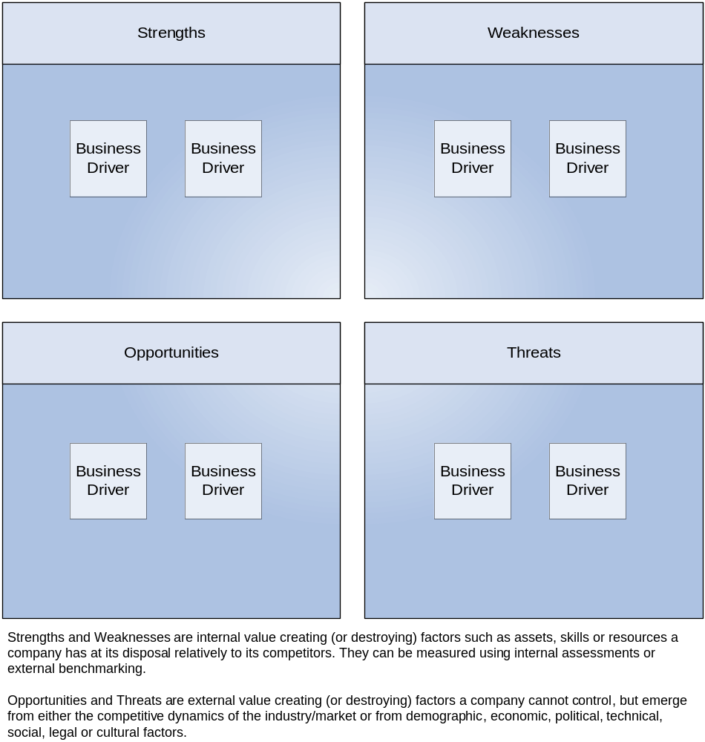
Figure 1: SWOT Diagram

Referenced Documents
Table 4: Referenced Documents lists all documents used to arrive at and/or referenced within this document (e.g., related and/or companion documents, prerequisite documents, relevant technical documentation, etc.).

Document Name | Issuance Date
 | <Month Day, Year>
Table 4: Referenced Documents

Glossary
This section defines the terms used in the document that may be unfamiliar to readers of the document.
Term Name | Definition | Source
Baseline Architecture | Describes the current ("as is") state of the agency in terms of performance, business, data, services, and technology. | FEA
Business Architecture | A functional perspective of the overall agency EA, providing information about the agency's baseline and target architectures. Examples of elements are:  - Agency business processes, aligned to business sub-functions within the FEA BRM  - Internal and external participants (roles) within these business processes  - Linkage between agency business processes and agency-specific performance measurement indicators  - Linkage between business processes to agency service components  - Agency programs, linked to business processes  - Offices and facilities. | FEA
Business Services | Defined by the agency business model, business services include the foundational mechanisms and back-office services used to achieve the purpose of the agency, e.g., inspections and auditing, direct loans, program monitoring, and financial management. | FEA
Conceptual Solution Architecture | The conceptual solution architecture defines the segment systems and services (e.g., business and information exchange) including the supporting technical and service components. | FEA
Core Mission Areas | Unique service areas that define the mission or purpose of the agency. Core mission areas are defined by the agency business model (e.g., tactical defense, air transportation, energy supply, pollution prevention and control, and emergency response). | FEA
Data Model | A data model in software engineering is an abstract model that describes how data is represented and accessed. Data models formally define data objects and relationships among data objects for a domain of interest. | FEA
Enterprise Architecture | A management practice for aligning resources to improve business performance and help agencies better execute their core missions. An EA describes the current and future state of the agency and lays out a plan for transitioning from the current state to the desired future state. | FEA
Performance Architecture | A perspective of the overall agency EA that provides information about the agency's baseline and target architectures. Examples of elements are:  - Agency strategic goals and objectives (as per the agency's Strategic Plan and IRM Plan) and linkage between performance indicators and business processes  - Agency-specific performance measurement indicators aligned to the generic measurement indicators described in the FEA PRM  - Linkage between the agency's strategic goals and investments. | FEA
Segment | Individual elements of the enterprise describing core mission areas and common or shared business services and enterprise services. Segments are defined by the enterprise architecture. | FEA
Segment Architecture | Detailed results-oriented architecture (baseline and target) and a transition strategy for a portion or segment of the enterprise. | FEA
Service | Discrete unit of functionality that can be requested (provided a set of preconditions is met), performs one or more operations (typically applying business rules and accessing a database), and returns a set of results to the requester. Completion of a service always leaves business and data integrity intact. | FEA
Solution Architecture | An architecture for an individual IT system that is part of a segment. A solution architecture is reconciled to the segment architecture above it. | FEA
Stakeholder | A person, group, organization, or system who affects or can be affected by an organization's actions. | FEA
Target Architecture | Describes the future ("to be") state of the agency in terms of performance, business, data, services, and technology. | FEA
Vision Statement | Summary description of the target business and information management environment to fulfill requirements, address change drivers, and achieve performance improvements. | FEA
Table 5: Glossary

Acronyms
This section provides a list of acronyms and associated literal translations used within the document.
Acronym | Literal Translation
EA | Enterprise Architecture
FEA | Federal Enterprise Architecture
Table 6: List of Acronyms

